Launch of the “Gathering of Talents” 19th and 20th June 2021
The address by Deanery members at the Launch Weekend during Sunday Masses 19th and 20th June for all the parishes within the Mountains Deanery.
“Go in Peace to love and serve the Lord.” With these final words at Mass we leave with a blessing to walk out to the world and share Christ’s love, peace, hope and healing to all. Our shared Eucharist can give us the vision and enthusiasm to reach beyond our Church pews.
One of the wonderful things about our communities is that we all have our own personalities and gifts, our own creative ways of being Christ like to each other. We all very familiar with the words of St Paul where he encourages us to see:
‘ There are different kinds of spiritual gifts, but the same Spirit gives them. (1 Cor 12: 4)
So despite being empowered and strengthened at Mass and despite our gifts, sometimes, we are at a loss to know how to reach out to others. This is why our Mountains Deanery, together, with the support of our Parish Councils/Teams are planning a Deanery wide “Sharing of Talents”. So, today is our Launch of the Gathering of Talents. This launch is across all the parishes in our Deanery. In this way we hope to share our sense of mission and have a deanery wide plan of action.
In each of our parishes there are many innovative ideas, successful ministries and outreach. We can learn from each other and challenge each other to greater achievements. Many hands make light work, so, our action plans should bear much fruit within and beyond all our local parishes.
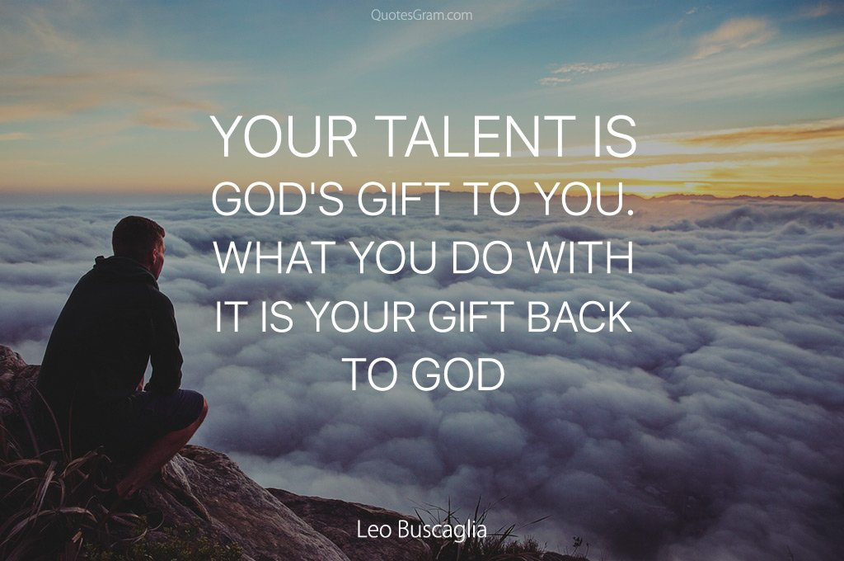

We can see much all around us. We can see and hear the pain and stress borne by many affected by the pandemic. There is homelessness, hunger, reduction in family incomes, disconnection, violence and loneliness. Hopefully, we can join together to work towards a better wider community.
So, today, we are distributing brochures outlining some forward planning. The Gathering of Talents will include workshops and all of this will be held on the 19th September at Springwood. On the brochure, we have listed some ideas for workshops such as Pastoral care/Outreach, social Justice and Sacramental Preparation and others.

We are inviting you to join us on Sunday 19th September. You can choose a workshop you are interested in, where your ideas as well as other ideas will be shared.
We are asking everyone to be a part of this process. So please complete the enclosed survey and put it in a box at the back of the church.
Our Church faces many challenges. It is now time for us all to step up and continue the work of Jesus at a new level. Thus, we will be making our Catholic Christian Community more compassionate, relevant and inclusive.
Let all our communities be encouraged by the words of Jesus at the Last Supper
“I am telling you the truth; whoever believes in me will do what I do-Yes they will do even greater things.” (John 14:12)
So, come along and see what we, the Catholic Community, can do!

